Use Case Realisation Report (Analysis) - Post Experience
FOR
Volunteer Management System
(VMS)

CLIENT
PROJECT | Volunteer Management System (VMS)Volunteer Management System
TITLE | Use Case Realisation Report (Analysis) - Post Experience
VERSION | 0.3a0.2a
DATE | 13-Aug-2011
 | ORIGINATOR
 | Name / Signature | Team 8S
 | APPROVAL
 | Name / Signature | Phung Kim Cuong, Dio
Institute of Systems Science |  | Document Reference
25 Heng Mui Keng Terrence  Singapore 119615 |  | VMS/T-1.4.1/1

 | Acceptance
 | Customer Signature |  | Customer Signature
 | Name & Designation |  | Name & Designation
 | Date & Company Stamp |  | Date & Company Stamp

Revision History

Date | Version | Description | Author
12-Jun-2011 | 0.1a | Creation | Team 8S
11-Aug-2011 | 0.2a | Updated | Team 8S
12-Aug-2011 | 0.3a | Updates | Team 8S

Table of Contents

1. Brief Description 3
2. Flow of Events 3
2.1 Standard Flow 3
2.2 Exceptions 3
3. Interaction Diagrams 4
3.1 Domain Collaboration Diagram: Post Experience 4
4. Participating Objects 4
4.1 Volunteer 4
4.2 UserStory 4
4.3 Document 4
4.4 ProjectDetailsScreen 4
4.5 UserStoryScreen 4
4.6 ProjectController 4
5. Class Diagram 5
6. Derived Requirements 5
ANNEX D Amendment History 5

Use Case Realisation Report (Analysis) - Post Experience

Brief Description
The use case enables registered user to propose new project.

Flow of Events
The standard flow of events for this use case and any exceptions are described in the following subsections. See section 3.1 for an overview of the participating Actors and Domain Objects.

Standard Flow

Precondition: Volunteer has logged in the system and use case View Project has been performed.This use case provides the user interface related functionality that will be provided to the User, as follows:
- When the Volunteer clicks ‘Post Experience’ button on the ViewProjectScreen, the ViewProjectScreen.postExperience() is triggered.
- ViewProjectScreen.postExperience() will use ProjectController.redirectURL() to redirect current screen to UserStoryScreen.
- After UserStoryScreen.show() method is triggered, a new form will be displayed enabling Volunteer to enter text.
- Volunteer can also upload documents by triggering UserStoryScreen.uploadDocument()
- After user click ‘Submit’ button, UserStoryScreen.onSubmit() will be triggered and it will trigger ProjectController.createUserStory() method
- ProjectController.createUserStory() will create a new UserStory object by using UserStory.create() with user input info.
- ProjectController.createUserStory() will create one or more Document objects by using Document.create() to save user uploaded docs or images.
- ProjectController.createUserStory() will use UserStoryScreen.displayMsg() to display a confirmation msg to the volunteer.
- The use case terminates.

Exceptions
The following exceptions have been identified:

Interaction Diagrams

Collaboration Diagram for Post Experience
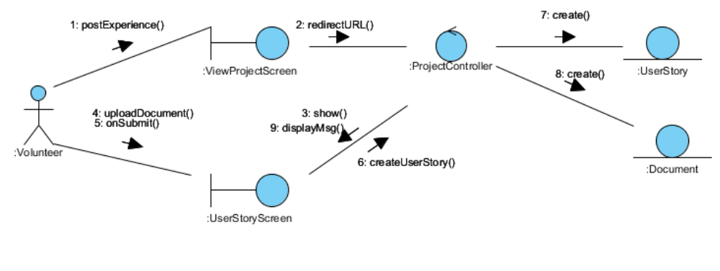

Participating Objects

Volunteer
This actor represents a person a volunteer who wishes to participate in doing volunteer work at project sites. He can be a project member or project leader for a project site. A volunteer can register himself as a volunteer in order to participate in the project site.

UserStory
This entity object stores the details concerning a user experience that volunteer created. The primary attribute that it holds is the userStoryID.

Document

This entity object stores the details concerning a document that volunteer uploaded. The primary attribute that it holds is the docID.ProjectDetailsScreen

ViewProjectScreen
This boundary object is used for collection of project details. User actor uses this object.

UserStoryScreen
This boundary object is used for collection of user story. The Volunteer actor uses this object.

ProjectController
This control object co-ordinates the creation, update, viewing and searching project record in the volunteer management system. It receives requests from the boundary objects allocated for the specific purposes, along with all the necessary details required for the execution of these requests.

Class Diagram

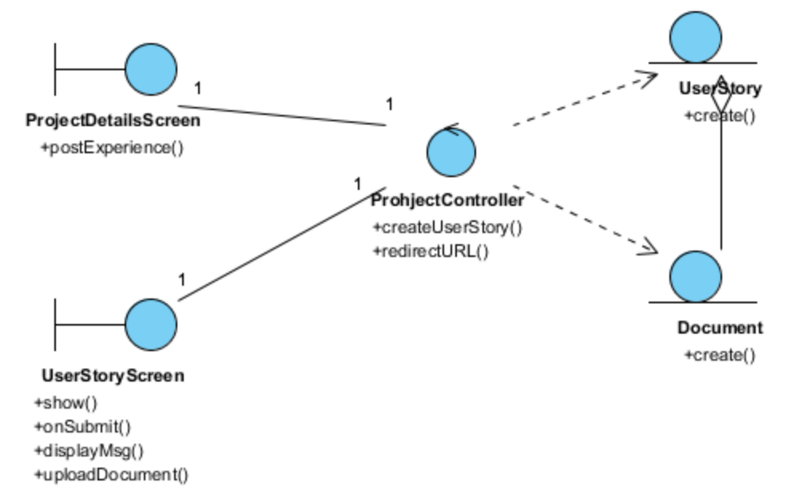

Derived Requirements

ANNEX D Amendment History
This is a record of all amendments made to the Document.

Version | Chapter / Section | Page No | Notes of Amendments or Changes

